FEBRUARY 2025
Subject: Happy, Healthy Heart


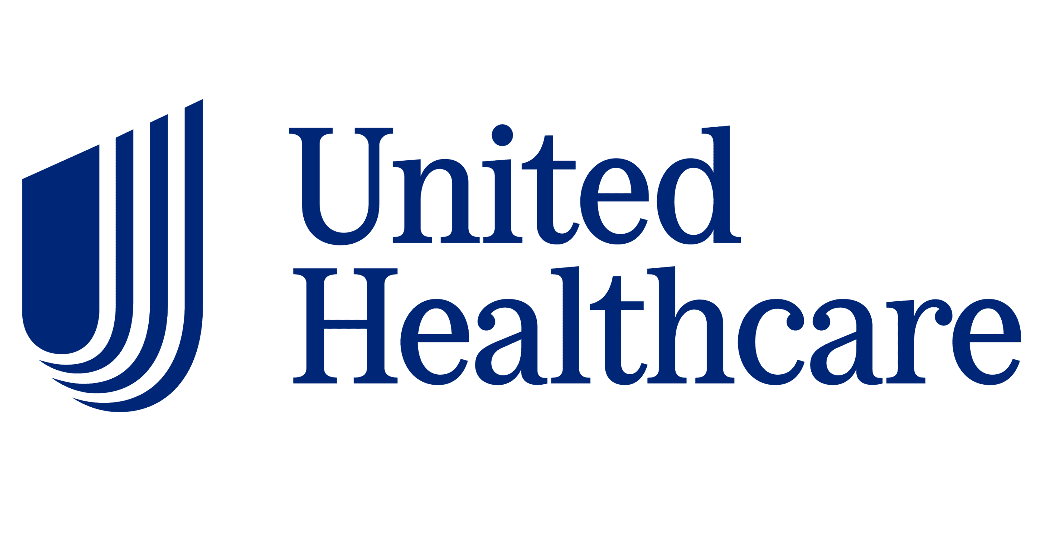  Did You Know…  Your heart pumps blood through 60,000 miles of blood vessels! That’s enough to circle the earth twice. | Ways to Be Heart Smart!  Did you know that heart disease is the leading cause of death for both men and women? Here are a few ways to be heart smart:  - Eat a balanced diet. Focus on fruits and veggies and limit saturated fats and added sugars.  - Get physical. Aim for 30 minutes of activity at least 5 days a week.  - Healthy sleep. Aim for 7-9 hours of sleep per night.  - Learn to manage stress. Find a few minutes every day to laugh, breathe deeply, stretch or walk.  UnitedHealthcare (UHC) provides lots of resources to help you learn more about heart disease. Even if you’re not enrolled in a TGNA UHC medical plan, take some time to review these tips for a healthy heart or this recorded presentation with more information.  Have questions about how to maintain good heart health? Schedule a preventive exam with your doctor to discuss. If you’re enrolled in a TGNA UHC medical plan, visit myuhc.com to find an in-network provider in the Choice Plus network.
”Eye” Spy a Healthy Heart  Screen time is a fact of life for so many of us, but there are ways to manage our eye health while using computers or mobile devices for work or play.  - Use the 20-20-20 rule: After every 20 minutes of screen time, take a 20-second break to look at something 20 feet away. And remember to blink frequently.  - Check the tech: Keep your device clean, install an anti-glare screen and set your monitor as bright as comfortable  - Ensure proper workspace design: Pull down window shades around your screen when sunlight is bright and keep surrounding lighting dim and balanced.  - Visit the eye doctor: Schedule your annual eye exam today!  As a reminder, if you’re enrolled in the TGNA EyeMed Vision Plan, you will pay only a $10 copay for your annual eye exam when you use an in-network provider. Visit eyemed.com or call 866-800-5457 to find a provider and schedule your exam today. |  | 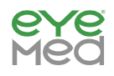  Did You Know…  An eye exam can detect early signs of heart disease. The retina's blood vessels are closely linked to the health of the heart. A dilated eye exam can detect changes in the blood vessels of the retina, which can indicate an increased risk of heart disease, stroke, or aneurysm.
Seek Support from the Employee Assistance Program (EAP)
Heart health isn’t just physical. When you're stressed, your body releases stress hormones like adrenaline and cortisol that cause your heart to beat faster, your blood vessels to constrict, and your blood pressure to rise, all of which can strain your heart. If you need help with anxiety, depression or are looking for resources to help with stress, contact the EAP. The EAP is available for immediate and confidential support by phone or online. Visit liveandworkwell.com (password: TGNA) or call 800-622-7276 to get started.
Want More Details About Your TG Benefits?
Visit our benefits website, tggroupbenefits.com (password: TGNA; location: United States).
There, you’ll find helpful information about all your benefits.

